Loan Portfolio Risk & Lending Strategy Dashboard
Data-driven insights to reduce default risk and optimize lending decisions (FY 2024)
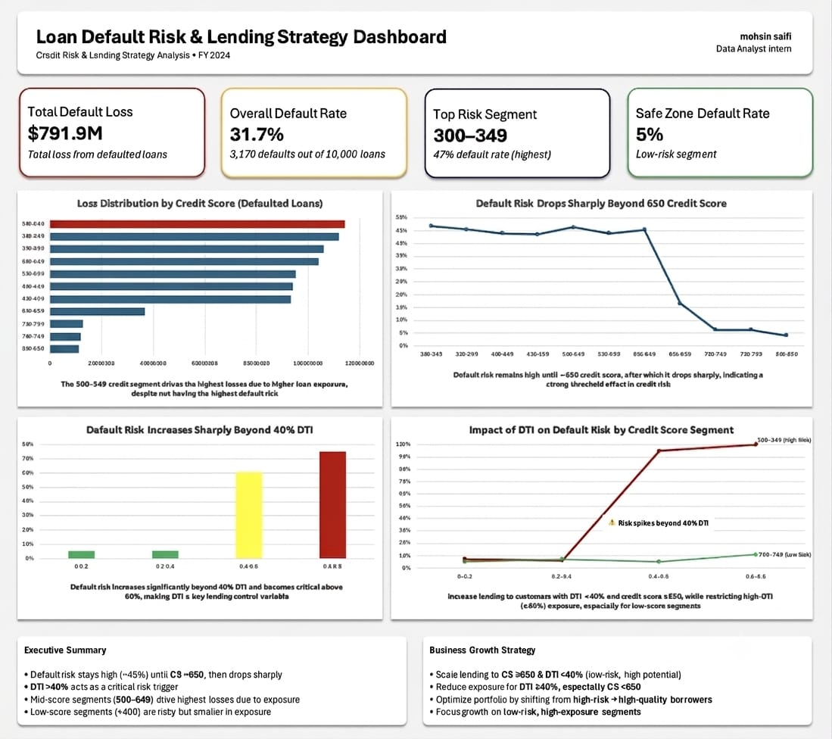

Mohsin Saifi
Data Analyst Intern

Objective
Identify key risk drivers, quantify loss concentration, and recommend data-driven strategies to optimize lending decisions.

Business Questions
- Where is the bank losing the most money?
- Which customer segments are high-risk?
- What factors drive loan defaults?
- Where can the bank safely increase lending?

Data Overview
Dataset of 10,000 loan records including:
- Credit Score (banded)
- Debt-to-Income Ratio (DTI)
- Loan Amount • Default Flag (0/1)
Derived features:
- Credit Score Bands
- DTI Bands
- Default Rate (%)

Key Insights
1. Loss Concentration
- Highest losses in 500–549 segment (~$114M)
- Driven by high exposure, not highest risk
2. Credit Risk Threshold
- Default rate ~45% until CS ~650
- Drops sharply beyond this point
3. DTI as a Risk Driver
- Low risk for DTI <40%
- Sharp increase beyond 40%, extreme above 60%
4. Interaction Effect (CS × DTI)
- Low-score borrowers highly sensitive to DTI
- High-score borrowers remain relatively stable

Business Impact
- Identified major loss concentration in mid-credit segments
- Highlighted high-risk exposure areas affecting portfolio quality
- Established clear thresholds (CS 650, DTI 40%) for risk control

Recommendations
- Scale lending to CS ≥650 & DTI <40%
- Restrict exposure for DTI ≥40%, especially CS <650
- Rebalance portfolio toward low-risk, high-quality borrowers
- Monitor high-risk segments with high exposure

Segment Strategy
Segment | Action
High Risk + High Exposure | Reduce
High Risk + Low Exposure | Monitor
Low Risk + High Exposure | Scale
Low Risk + Low Exposure | Maintain

Conclusion
Financial losses are driven more by exposure concentration than default probability alone.
Combining credit score thresholds and DTI controls enables both risk reduction and strategic growth.

Tools Used
- Microsoft Excel (Pivot Tables, Dashboarding)
- Data Visualization
- Risk Segmentation Analysis

Project Outcome
Developed a decision-focused dashboard that:
- Identifies key risk drivers
- Highlights loss concentration
- Provides actionable lending strategy

Key Takeaway
Effective lending requires balancing risk (default rate) and exposure (loan volume) while considering how multiple factors interact.

